**Correctness of the OO Program**

**No of test cases: 10**

**No of test cases Passed: 10**

**QA Status: PASS**

**Execution Screenshot for reference:**

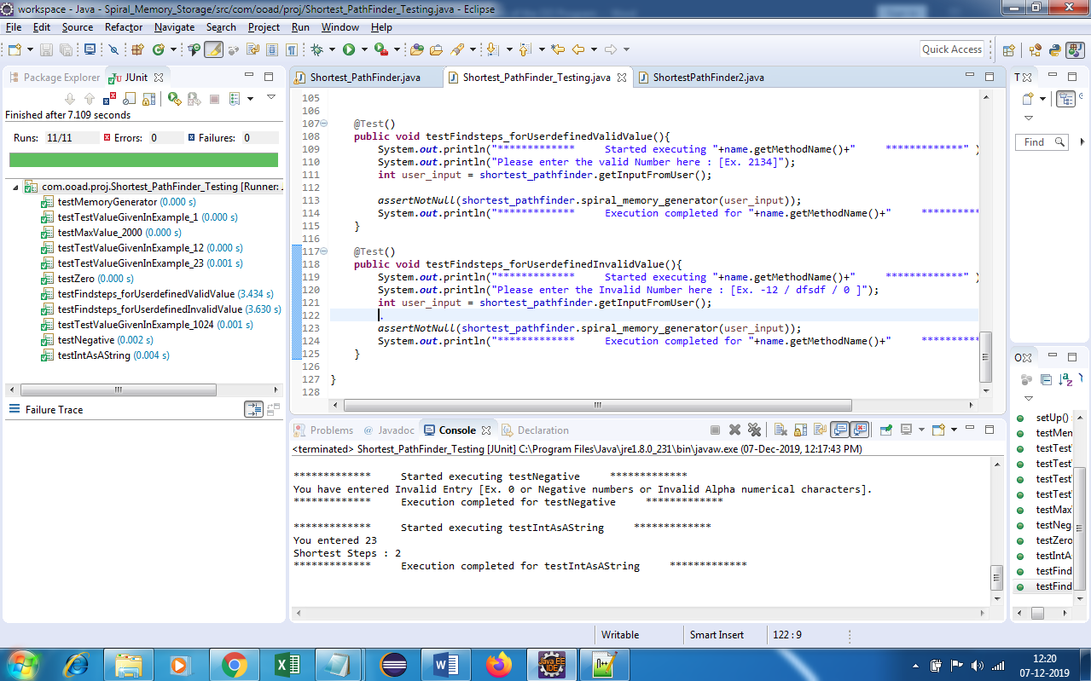

**Test Execution Console Logs:**

************* Started executing testTestValueGivenInExample_1 *************

You entered 1

Shortest Steps : 0

************* Execution completed for testTestValueGivenInExample_1 *************

************* Started executing testMaxValue_2000 *************

You entered 2000

Shortest Steps : 25

************* Execution completed for testMaxValue_2000 *************

************* Started executing testTestValueGivenInExample_12 *************

You entered 12

Shortest Steps : 3

************* Execution completed for testTestValueGivenInExample_12 *************

************* Started executing testTestValueGivenInExample_23 *************

You entered 23

Shortest Steps : 2

************* Execution completed for testTestValueGivenInExample_23 *************

************* Started executing testZero *************

You have entered Invalid Entry [Ex. 0 or Negative numbers or Invalid Alpha numerical characters].

************* Execution completed for testZero *************

************* Started executing testFindsteps_forUserdefinedValidValue *************

Please enter the valid Number here : [Ex. 2134]

Enter an integer: 2345345345

You have entered Invalid Entry [Ex. 0 or Negative numbers or Invalid Alpha numerical characters].

************* Execution completed for testFindsteps_forUserdefinedValidValue *************

************* Started executing testFindsteps_forUserdefinedInvalidValue *************

Please enter the Invalid Number here : [Ex. -12 / dfsdf / 0 ]

Enter an integer: erfgtdou9dfio

You have entered Invalid Entry [Ex. 0 or Negative numbers or Invalid Alpha numerical characters].

************* Execution completed for testFindsteps_forUserdefinedInvalidValue *************

************* Started executing testTestValueGivenInExample_1024 *************

You entered 1024

Shortest Steps : 31

************* Execution completed for testTestValueGivenInExample_1024 *************

************* Started executing testNegative *************

You have entered Invalid Entry [Ex. 0 or Negative numbers or Invalid Alpha numerical characters].

************* Execution completed for testNegative *************

************* Started executing testIntAsAString *************

You entered 23

Shortest Steps : 2

************* Execution completed for testIntAsAString *************